***A Mini Project Report on***

**Home Service Provider**

**T.E. - I.T Engineering**

**Submitted By**

**Pooja Sharma 20104090**

**Nainisha Sharma 20104042**

**Dhruvi Haria 20104012**

**Under The Guidance Of**

**Prof. Jayshree Jha**



**DEPARTMENT OF INFORMATION TECHNOLOGY**

A.P. SHAH INSTITUTE OF TECHNOLOGY

G.B. Road, Kasarvadavali, Thane (W), Mumbai-400615

UNIVERSITY OF MUMBAI

**Academic year: 2022-23**

**CERTIFICATE**

This to certify that the Mini Project report on Home Service Provider has been submitted by **Pooja Sharma (20104090), Nainisha Sharma (20104042) and Dhruvi Haria (20104012)** who are a Bonafede students of A. P. Shah Institute of Technology, Thane, Mumbai, as a partial fulfilment of the requirement for the degree in **Information Technology**, during the academic year **2022-23** in the satisfactory manner as per the curriculum laid down by University of Mumbai.

Prof. Jayshree Jha

Guide

Dr. Kiran Deshpande Dr. Uttam D. Kolekar

Head Department of Information Technology Principal

External Examiner(s)

1.

2.

Place: A.P. Shah Institute of Technology, Thane

Date:

**ACKNOWLEDGEMENT**

This project would not have come to fruition without the invaluable help of our guide **Prof. Jayshree Jha**. Expressing gratitude towards our HoD, **Dr. Kiran Deshpande**, and the Department of Information Technology for providing us with the opportunity as well as the support required to pursue this project. We would also like to thank our teacher **Ms. Yaminee Patil** who gave us her valuable suggestions and ideas when we were in need of them. We would also like to thank our peers for their helpful suggestions.

**ABSTRACT**

It is difficult for customer to find any service in emergency at any time and place. So, with this project we are going to develop website which will help customers to find out solution for any problems related to Cleaning, Pest Control, Plumbing, Electronic repairing, Home Paint and Movers & Packers service. Our website will provide a platform for all kind of house hold services at any time and place. Our project will also provide the facilities like booking service, online payment and authenticated user login. The on-demand home service system is incredibly useful for everybody who wants to urge home services.

**TABLE OF CONTENTS**

1. Introduction……………………………………………………………………...6
   1. Purpose........................................................................................................ 7
   2. Problem Statement…………………………………………………………7
   3. Objectives.................................................................................................... 8
   4. Scope........................................................................................................... 8
2. Literature Review………………………………………………………….…....9
3. Proposed System………......................................................................................12
   1. Features and Functionality……………………………………………..…12
4. Requirements Analysis........................................................................................ 13
5. Project Design......................................................................................................16
   1. Use Case diagram………………………………………………………… 16
   2. DFD (Data Flow Diagram) ………………………………………………..19
   3. System Architecture……………………………………………………….20

5.3.1. Working of home service provider website …………………………22

1. Technical specification……………...…………………………………………...25
2. Project Scheduling................................................................................................. 28
3. Implementation…………………………………………………………………..29

9. Result and Discussion……………………………………………………………..34

1. Conclusion and Future Scope................................................................................41

References

Chapter 1

Introduction

There was a time when looking for a mechanic, finding a electrician, looking for a cleaner, or getting the washing machine fixed used to be a hectic task. Everyone need a home service provider frequently, be it cleaning, changing a bulb, repairing a pipe leakage, pest control, etc. When someone needs aid with small and major household tasks, trouble arises when service skilled persons are unavailable or the trusted providers are impossible to find, who deliver consistently flawless service. And finding someone new who would do the work perfectly on the stop is not an easy task. Also, now-a-days everyone is busy with today’s hustle-bustle life because of which they don’t have time to search for workers who can work professionally and do the home service on time.

To solve all those problems, we have designed a home service provider website. Our online website for household services provides the most expedient and easy way to get your domestic work done. Home Service provider is a solution to sort all your home needs ranging from construction to maintenance, quickly, professionally and conveniently. We aim to help in providing optimal solutions to all household troubles with more efficiency, ease and majorly, a delicate touch.

The basic purpose of our website is to provide all kinds of services at customer’s doorsteps with a one-stop solution to make their life easy and convenient anywhere at any time by nearest service provider company. The home service provider website is designed in an easy way so that the customer won’t have to waste their time on understanding the working of the website.

* 1. Purpose

1. The purpose of Home Service Provider website is to provide services related to home to customers easily by just selecting the services that they want. These on-demand home service website aids people in managing their busy lives. These website enables people to hire someone to manage their household chores or daily chores where they’d need constant help. It could be anything, including cleaning, plumbing, painting, moving and organization.
2. With this website, the customer can easily get the service that they want. The website focuses on providing service to the customer professionally and cost effectively. The user will have many options to choose from and can also provide feedback to share their experience.
   1. . Problem Statement

When someone needs aid with small and major household tasks, trouble arises when service skilled persons are unavailable or the trusted providers are impossible to find, who deliver consistently flawless service. And finding someone new who would do the work perfectly on the stop is not an easy task. Also, many times when we find the required service that we want, problems can also arise if the service is costly. To find a service that is under budget and that provides professional workers is very hard. A great deal of time has to be invested just to find the right worker for home service.

* 1. . Objectives
* To deliver the service at the door-step with least effort.
* To provide a medium to avail services from qualified experts in field.
* To provide quality services in quickest possible way.
* To create a user efficient environment to provide smooth experience.
* To provide trusted and authenticate experts.
* To reduce manual work for customer in finding the required service.
* To develop a web based online system for opting household services.
  1. Scope
* Addition of variety of other services to provide to the customer.
* Increasing the number of service providers to deliver the service more efficiently.
* Increase the ways to collect more customer feedbacks to improve the service.
* Test the service provider on more grounds to hire only expert and qualified person.
* Improve the user interface to provide more easy access to the functions

Chapter 2

Literature Review

Literature 1

**An Android Application for Home Services by Sharaj Bhaskar Shyamala, Krishnamoorthy Rao, Padmanabha Bhandarkar, Prateek Prakash Vetekar, Geetha Laxmi.**

The proposed system is an application for home service and explains deeply about how business has been shifted to online and how many new businesses have made people's lives easier. With the world changing so fast, one will need to adjust with new technology. To find the right people for right home service the customer needs to throw in some of their time and effort and sometimes even after all the efforts, the service might not be good and the customer might just be wasting their time.

Home Service Provider provides customer with home services by just selecting the service they want. In this paper we also learn about existing home service like Urban Clap, Forfix and Handyman. The customers can get various type of service in one place instead of searching for different home service in different places. The trusted home services application with professional and qualified personnel can repair and fix everything around your home in an efficient manner.

The proposed system also explains about the application through Architecture Design, use case diagram, Data flow diagram, Sequence diagram and control flow diagram which gives us more closure about the home service application. More companies are opting for a visitor management system without a receptionist in other word unattended reception box. This is because of cost-savings and because of the following three factors: A digital welcome shortens the waiting time of the visitor. An automatic reception also means there is a safe visitor register which complies with GDPR. Unattended reception box is the most comfortable way to receive items for the customer.

Literature 2

**An Online Service for Household Services by N. M. Indravasan, Adarsh G, Shruthi C, Shanthi K, Dadapeer.**

The proposed system is basically a marketplace for household services and it is the platform where the rates were standardized and there is no necessitate haggling over prices. The primary objective of the online system for house hold services is about delivering the home services at the doorstep just by one click. This paper discusses about main theme of the online home services, numerous services provided and how the ordering and delivery of services takes place.

Online system for household services can be used by any authorized user intending to seek for household services through an ingenious web-based system or a mobile application. After booking a service, an external payment gateway guarantees a secure and safe transaction. Proposed system involves three actors which include an Admin, Service provider, and a customer. A systematic mobile environment to system clients offers clients a more comfortable way of accessing services such as home cleaning, plumbing, maintenance, electrical works, appliance repair, painting, vehicle service and many other services to be done in a click anytime from anywhere as easy as possible.

Technology Used in The Given System:

1.WordPress:

WordPress provides a free payment gateway called Woo commerce. This Woo Commerce plug-in is combined with a business account from Inspire Commerce. It will allow you to accept all major credit cards such as Visa, MasterCard, American Express, Discover, Diners Club, JCB.

2. PHP:

PHP is one of the most widespread programming languages for building server-side web applications. Like other scripting languages, PHP includes a number of dynamic language features, such as an eval expression to run code provided at runtime as strings. The major challenge for resolving software configuration errors is aggravated in multi-layer systems.

Literature 3

**An Online System for Home Services by Ms. Prachi S. Tambe, Nikam Poonam, Gunjal Trupti, Jadhav Priti, Parakhe Sonali.**

Home service website is for giving best service to a customer. Website is all about the solution of the problem which occurs in our day-to-day life. The workers which will come to your door step are trustable and an experienced so that cannot be doubtable. In website there are many types of service which are provided to the users. Website is made user-friendly to attract the users. Rates are standardized and affordable for the users. E-website for home-based service can reduce the stress of finding well qualified and professional workers.

Hardware requirements are phone and laptop.

The technology which is used are:

Frontend: - Java

Backend: - MySQL

Operating System: - Windows 10

Chapter 3

Proposed System

The home service provider website will be able to provide the required service to the customer and will also provide job opportunity for workers looking for jobs related to home service. Through this website the user will be able to get the service that they want while saving their time. We have designed the website in such a way that the customer will be able to book the service by simply choosing the service they want. Several aspects like home cleaning, pest control, plumbing, electrical works, painting and movers & packers services are involved in a website to provide happy and healthy home atmosphere in order to satisfy consumers.

* 1. Features and Functionality
* Service Booking: Customers can book services whichever they want.
* The customer will be booking the services securely by using the credential that they have created while registration.
* Only validated values will be taken and invalid will not.
* Customer can also give feedback to the service that they receive.
* Customers can also view testimonial of other customers that have posted their feedback.
* Only Validated worker would be able to access their dashboard and also will be able to give feedback.
* Admin will have information regarding the customers and worker.

Chapter 4

Requirement Analysis

4.1. Feasibility Study

Feasibility study is carried out when there is a complex problem or opportunity. It is considered as the primary investigation which emphasizes on “Look before You Loop” approach to any project. A Feasibility study is undertaken to determine the possibility of either improving the existing system or developing a completely new system.

We are going to developed the new system which is feasible as our website is very user friendly and easy to understand.

4.2. Technical Feasibility

In this type of study, the current technology in used in an organization is checked such as the existing software, hardware, and personnel staff to determine whether it will work for the proposed system or completely new ones is to be used. The proposed system is capable of adding, changing, enhancing functionality, features etc. The proposed system is capable of handling large storage of data. The back-end and front-end technology has greater important for providing an accurate, error-free, frequencies of data to be used.

Our project is technically feasible in terms of current technology.

4.3. Functional Requirement

These are the requirements that the end user specifically demands as basic facilities that the system should offer. All these functionalities need to be necessarily incorporated into the system as a part of the contract. These are represented or stated in the form of input to be given to the system, the operation performed and the output expected.

Functional Components:

1. Service Attributes:

Service page has been designed to provide easy information about what that particular service provides. The services are classified into categories for easy searching when in need.

2. Order & Checkout Flow:

The flow of order is kept simple to avoid complexity and fast booking. The customer can directly order from the service page after selecting the needed service. The “Select “ option will directly add the service to cart from where the customer can confirm the order.

3. Order History;

The user can check their order history for further reference and can reduce the searching time for the future orders.

4. Reviews and Feedback:

The user can check the rating of the workers who are delivering the services.

And users can provide feedback about their experience and provide more suggestion and scope of improvement.

4.4. Non-Functional Requirement

These are basically the quality constraints that the system must satisfy according to the project contract. The priority or extent to which these factors are implemented varies from one project to other. They are also called non-behavioral requirements.

1. Usability:

The website is kept simple so that even non-technical person can use it easily. They can quickly they can perform tasks in the store. There is not much searching required to get the service customer need.

2. Scalability:

The online household services application provides some of the home services which are most frequently used. This system accommodates the changing needs of the end user.

The overall system can be designed so that its capacity can be increased in response to the further requirements for which the application provides an appropriate service

overseas. Further this application can be prolonged by merely adding up the required services and additional payment systems. For example, the current system provides

the following services such as home painting, home cleaning, packers and movers, plumber repair and service further the system can be extended as per the requirements

of the user. The system can have prolonged by adding the services such as mobile and computer repair, laundry services, catering services and many more. The discussion

payment methods our system has, for example currently system has online payment by only MasterCard users further it can be extended by adding the payment services for visa users also.

Chapter 5

Project Design

5.1. Use Case Diagram

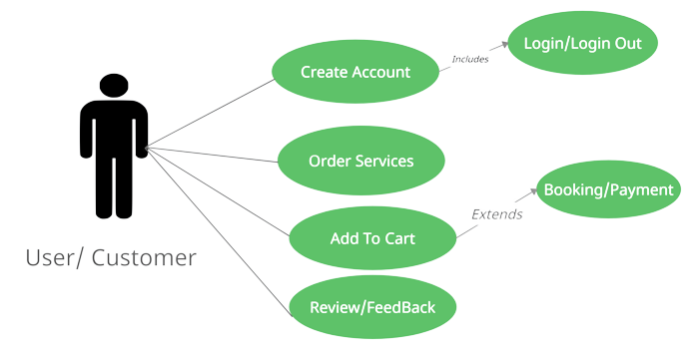

Fig 5.1. Use Case for User/Customer.

* The new user will be first creating an account by registering themselves through register page.
* If the user already has an account, they can directly login into the website through login page.
* The user can select any type of service that they want through service page.
* After selecting the service, the user will be making payment through payment portal.
* The user can also give his/her feedback to the website through feedback page.

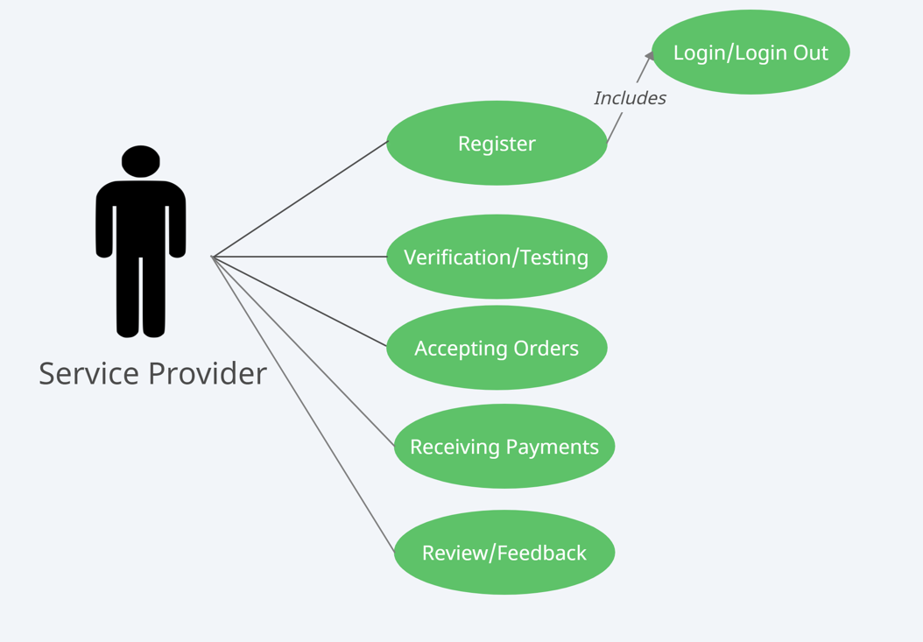

Fig 5.2. Use Case for Service Provider.

* The service provider/worker will first have to register themselves to the website through register and also provide a resume so that the admin can decide to hire them or not.
* If the worker is already registered then they just need to login through login page.
* The worker will be accepting work from their work page and will receive payment accordingly.
* The worker can also give feedback and review through feedback page.

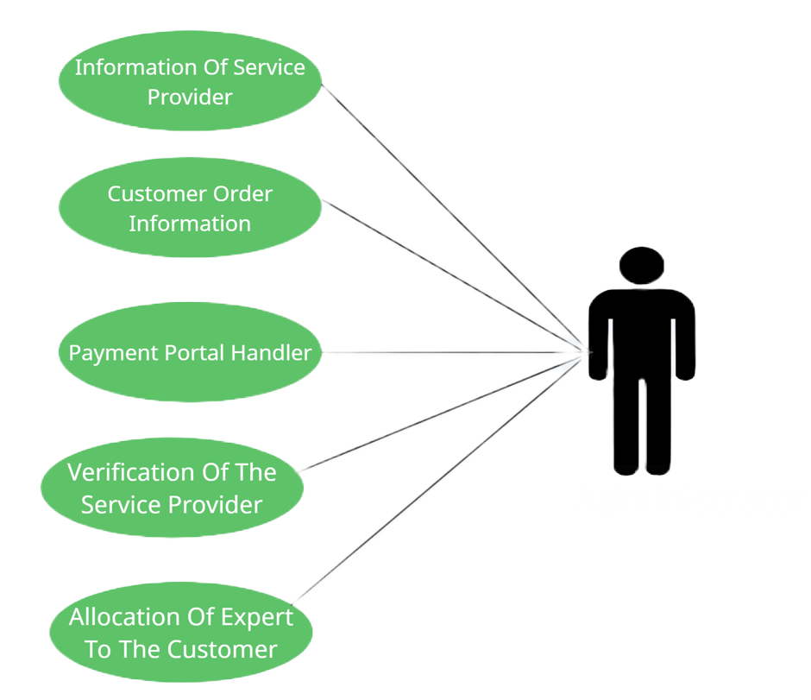

Fig 5.3. Use case for Admin.

* The admin will be able to view the workers profile and will also be responsible to view their profile and decide if the worker should be hire or not.
* The admin will also be able to view customer’s information and their past order history.
* The admin will also be responsible to allocate the expert to the customers.
* The admin will also be handling issues related to payment.

5.2. Data Flow Diagram (DFD)

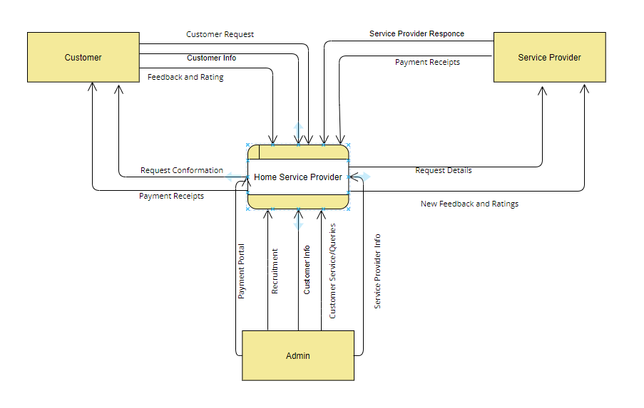

Fig 5.2.1. DFD level 0

* The figure explains about customer, admin and service provider interact with each other through Home Service website.

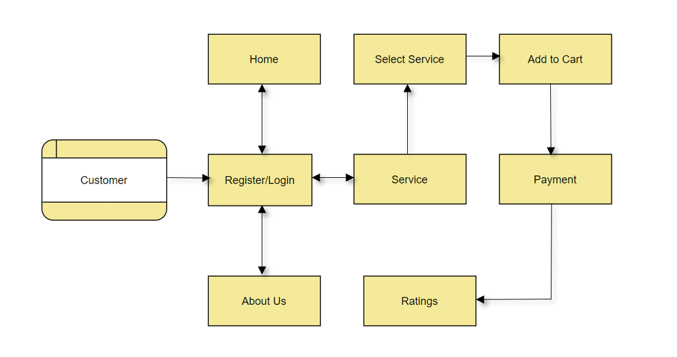

Fig 5.2.2. DFD level 1

* The figure explains how the customer would access the service from the website.
* The customer would be logging into the website by providing the credentials that they created during registering themselves.
* The customer will be selecting the service as per there requirement and add to cart from there they cam make the payment for the service that they have chosen.
* The customer also have feedback facility from which they can provide there valuable feedback related to the website and service.

5.3. System Architecture

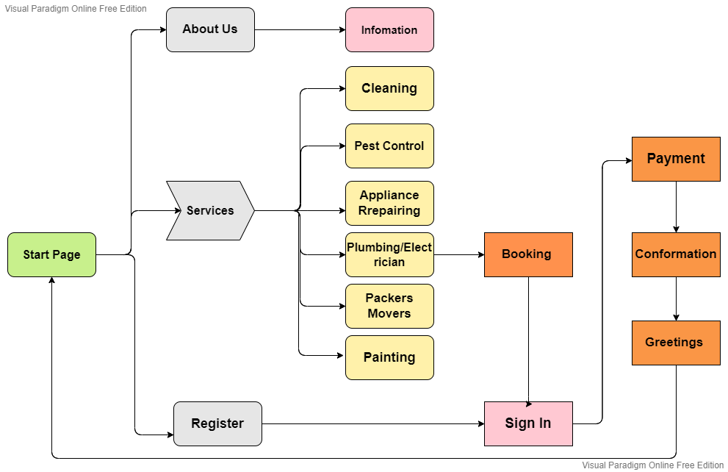

Fig 5.3.1. Flow Diagram of Home Service Provider Website.

The flow of Home Service Provider website is as follow:

* The user will be first taken to the home page of the website.
* If the user is new to the website, then they can register for the website by clicking register button through which the user will be taken to the register page.
* If the user already has an account, then they can directly login to their account through login button.
* The user can go to service page by selecting the service link from the tab upward and select the service they want.
* The service from which the user can choose are cleaning service, pest control service, appliance repairing service, plumbing & electricity service, movers & packers service and painting service.
* Inside each service the user has different option related to that service and after choosing the particular service that they want the user will be taken to the payment portal where they would be ask to enter required information regarding the service.
* After payment the user will get the service that they want.

PAGES:

* Home Page: Customers can view the main services, testimonial and contact information on home page.
* Register Page: Customer can register for an account if they are a new user by filling the required information.
* Login Page: Customer can login in their account if they already have created an account by entering valid credentials.
* About Us Page: Customer can view the information about the website.
* Service Page: Here the customer will be able to select main home services that they want.
* Cleaning Service Page: The customer will be able to choose any type of cleaning service that they want. Cleaning services include full home cleaning, kitchen cleaning, bathroom cleaning, sofa cleaning and carpet cleaning.
* Pest Control Service Page: The customer will be able to choose any type of Pest control service that they want. Pest control service include rodenticide treatment, insecticide treatment and bed bud treatment service.
* Appliance Repairing Service Page: The customer will be able to choose any type of appliance repairing service that they want. Appliance repairing service includes AC, refrigerator, TV, washing machine, kitchen appliance and geyser repairing service.
* Plumbing & Electricity Service Page: The customer will be able to choose any type of Plumbing & electricity service that they want. This service includes pipe leakage repairing, pipe changing, wire sort and light changing services.
* Packers & Movers Service Page: The customer will be able to choose any type of Packers & movers service that they want. This service includes full packers & movers service, truck service and movers to truck service.
* Painting Service Page: The customer will be able to choose any type of painting service that they want.
* Cart Page: The customer will be able to see the services that they have chosen in cart page.
* Order Page: The service that the customer has booked previously or the service that is on the way is displayed on this page.
* Worker Page: Worker can view their next work location, work history, payment and can also give their feedback.
* Admin Page: Admin can view the customers and workers information and will also receive the feedback that they will provide.

**5.3.1. Working of Home service provider website:**

1. REGISTER NEW USER:

Description of feature:

This feature can be performed by user to create an account.

Functional Requirement:

* System must be able to store information that the user gave as input.
* System must allow only if correct input is given by the user.

1. USER LOGIN

Description of feature:

This feature is used by users to login into the website by entering valid credentials that they used while creating their account.

Functional Requirement:

* The website must only allow user with valid credentials to have an access to the required service. If the user has put invalid credentials, then they should not be allowed to book any service.

1. CHOOSING SERVICE

Description of feature:

This feature is used by customers to choose the home service that they want.

Functional Requirement:

* The website must provide valid home service to the customers and must make sure that the service that the customer is choosing is the one they got.

1. PAYMENT PORTAL

Description of feature:

This feature is used by customers to make payment for the service that they choose.

Functional Requirement:

* The system must only allow valid input.
* The system must be able to provide the required service to the customers after the payment is done and should be able to provide types of payment.

1. ADMIN PORTAL

Description of features:

This feature is used by the admin to view information regarding the customer and worker and the admin will also receive the feedback provided by customer and worker

Functional Requirement:

* The system must be able to provide customers and admin information.
* The system must only provide correct information to the admin.

1. WORKER PORTAL

Description of features:

This feature is used by the worker to view the next work place and to provide their feedback.

Functional Requirement:

* The system should be able to provide the next location of the place that the worker is supposed to go.
* The system should be able to provided only correct information to the worker.

Chapter 6

Technical Specification

Front End: HTML, CSS & JavaScript

Back End: XAMPP, PHP

Front End:

HTML:

The Hypertext Markup Language or HTML is the standard [markup language](https://en.wikipedia.org/wiki/Markup_language) for documents designed to be displayed in a [web browser](https://en.wikipedia.org/wiki/Web_browser). It can be assisted by technologies such as [Cascading Style Sheets](https://en.wikipedia.org/wiki/Cascading_Style_Sheets) (CSS) and [scripting languages](https://en.wikipedia.org/wiki/Scripting_language) such as [JavaScript](https://en.wikipedia.org/wiki/JavaScript).

[Web browsers](https://en.wikipedia.org/wiki/Web_browser) receive HTML documents from a [web server](https://en.wikipedia.org/wiki/Web_server) or from local storage and [render](https://en.wikipedia.org/wiki/Browser_engine) the documents into multimedia web pages. HTML describes the structure of a [web page](https://en.wikipedia.org/wiki/Web_page) [semantically](https://en.wikipedia.org/wiki/Semantic_Web) and originally included cues for the appearance of the document.

[HTML elements](https://en.wikipedia.org/wiki/HTML_element) are the building blocks of HTML pages. With HTML constructs, [images](https://en.wikipedia.org/wiki/HTML_element#Images_and_objects) and other objects such as [interactive forms](https://en.wikipedia.org/wiki/Fieldset) may be embedded into the rendered page. HTML provides a means to create [structured documents](https://en.wikipedia.org/wiki/Structured_document) by denoting structural [semantics](https://en.wikipedia.org/wiki/Semantics) for text such as headings, paragraphs, lists, [links](https://en.wikipedia.org/wiki/Hyperlink), quotes and other items.

In our Project, we have used HTML as our main language for creating a website. Most of the pages in our project are in html.

CSS:

Cascading Style Sheets (CSS) is a [style sheet language](https://en.wikipedia.org/wiki/Style_sheet_language) used for describing the [presentation](https://en.wikipedia.org/wiki/Presentation_semantics) of a document written in a [markup language](https://en.wikipedia.org/wiki/Markup_language) such as HTML or XML. CSS is a cornerstone technology of the [World Wide Web](https://en.wikipedia.org/wiki/World_Wide_Web), alongside HTML and [JavaScript](https://en.wikipedia.org/wiki/JavaScript).

CSS is designed to enable the separation of presentation and content, including [layout](https://en.wikipedia.org/wiki/Page_layout), [colors](https://en.wikipedia.org/wiki/Color), and [fonts](https://en.wikipedia.org/wiki/Typeface). This separation can improve content [accessibility](https://en.wikipedia.org/wiki/Accessibility); provide more flexibility and control in the specification of presentation characteristics; enable multiple [web pages](https://en.wikipedia.org/wiki/Web_page) to share formatting by specifying the relevant CSS in a separate .css file, which reduces complexity and repetition in the structural content; and enable the .css file to be [cached](https://en.wikipedia.org/wiki/Cache_(computing)) to improve the page load speed between the pages that share the file and its formatting.

In our project we have used CSS to style all the pages and link the css file to respective html and php file.

JavaScript

JavaScript (JS) is a light-weight object-oriented programming language which is used by several websites for scripting the webpages. It is an interpreted, full-fledged programming language that enables dynamic interactivity on websites when applied to an HTML document. It was introduced in the year 1995 for adding programs to the webpages in the Netscape Navigator browser. Since then, it has been adopted by all other graphical web browsers. With JavaScript, users can build modern web applications to interact directly without reloading the page every time.

Although, JavaScript has no connectivity with Java programming language. The name was suggested and provided in the times when Java was gaining popularity in the market. In addition to web browsers, databases such as CouchDB and MongoDB uses JavaScript as their scripting and query language.

Back End:

XAMPP

XAMPP  is a [free and open-source](https://en.wikipedia.org/wiki/Free_and_open-source) [cross-platform](https://en.wikipedia.org/wiki/Cross-platform) [web server](https://en.wikipedia.org/wiki/Web_server) [solution stack](https://en.wikipedia.org/wiki/Solution_stack) package developed by Apache Friends, consisting mainly of the [Apache HTTP Server](https://en.wikipedia.org/wiki/Apache_HTTP_Server), [MariaDB](https://en.wikipedia.org/wiki/MariaDB) [database](https://en.wikipedia.org/wiki/Database), and [interpreters](https://en.wikipedia.org/wiki/Interpreter_(computing)) for scripts written in the [PHP](https://en.wikipedia.org/wiki/PHP) and [Perl](https://en.wikipedia.org/wiki/Perl) [programming languages](https://en.wikipedia.org/wiki/Programming_language). Since most actual web server deployments use the same components as XAMPP, it makes transitioning from a local test server to a live server possible.

XAMPP's ease of deployment means a [WAMP](https://en.wikipedia.org/wiki/WAMP) or [LAMP](https://en.wikipedia.org/wiki/LAMP_(software_bundle)) stack can be installed quickly and simply on an operating system by a developer, with the advantage that common add-in applications such as [WordPress](https://en.wikipedia.org/wiki/WordPress) and [Joomla!](https://en.wikipedia.org/wiki/Joomla!) can also be installed with similar ease using [Bitnami](https://en.wikipedia.org/wiki/Bitnami).

PHP

PHP is an open-source, interpreted, and object-oriented scripting language that can be executed at the server-side. PHP is well suited for web development. Therefore, it is used to develop web applications (an application that executes on the server and generates the dynamic page.).

PHP was created by **Rasmus Lerdorf in 1994** but appeared in the market in 1995. **PHP 7.4.0** is the latest version of PHP, which was released on **28 November**.

In our project, we have use php admin for database for different pages such as register page, login page, etc.

Chapter 7

Project Scheduling

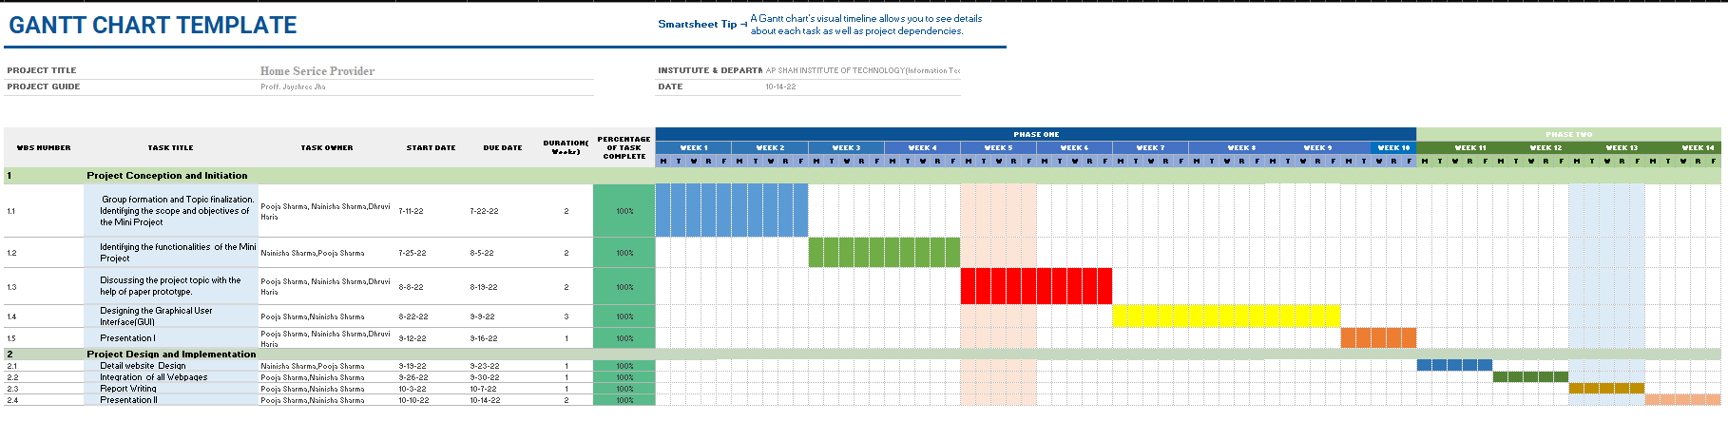

Chapter 8

Implementation

**User Interface**

User Interface is concerned with the dialogue between a user and the computer. It is concerned with everything from starting the system or logging into the system to the eventually presentation of desired inputs and outputs. The overall flow of screens and messages is called a dialogue.

The following steps are various guidelines for user interface:

1. The system user must always be aware of what to do next.

2. The system must be able to satisfy the user requirement.

3. The system must only take valid inputs.

**Various Table are made in database to maintain records:**

* Customer Register Table:

In this table, data regarding the customers is stored which is provided by the customers during registering themselves into the website. Data include in this table are name, address, image of customer Aadhar card, etc.

* Worker Register Table:

In this table, data regarding the workers is stored which is provided by the workers during registering themselves into the website. Data include in this table are name, address, image of worker Aadhar card, workers resume in pdf, etc.

* Customer Login Table:

In this table, the credential that is store in customer register table will also be stored here.

* Worker Login Table:

In this table, the credential that is store in customer register table will also be stored here.

* Cart:

In this table, service that the user has selected is stored.

Payment Portal:

Through our payment portal user can make payment for the selected services. There are various payment options available on the portal so that user can use it conveniently.

Code:

<header>

<div class="container">

<div class="left">

<h3>PAYMENT PORTAL</h3>

<img src="images/homeservice.jpg">

<div class="right">

<form>

Accepted Card<br>

<iconify-icon icon="cib:cc-visa"></iconify-icon>

<iconify-icon icon="logos:mastercard"></iconify-icon><br>

Card Holder Name

<input type="text" name="" placeholder="Enter Card Holder Name">

Card Number

<input type="number" name="" placeholder="Enter Card Number">

<div id="zip">

<label>

Exp Month<br>

<select style="margin-top: 10px;width: 200px;">

<option>Choose Month</option>

<option>1</option>

<option>2</option>

<option>3</option>

<option>4</option>

<option>5</option>

<option>6</option>

<option>7</option>

<option>8</option>

<option>9</option>

<option>10</option>

<option>11</option>

<option>12</option>

</select>

</label>

<label class="zippp">

Exp Year<br>

<select style="margin-top: 10px;width: 200px;">

<option>Choose Year</option>

<option>2022</option>

<option>2023</option>

<option>2024</option>

<option>2025</option>

<option>2026</option>

<option>2027</option>

<option>2028</option>

</select>

</label>

<label class="zippp">

CVV

<input type="number" name="" placeholder="Enter CVV" style="width: 200px;">

</label>

</div>

</form>

<input type="submit" name="" value="Proceed to Pay">

<a href="#"><button type="button">Back</button></a>

</div>

</div>

</header>

Cart:

Through cart function the user can add service to the cart and then book all the added services collectively. This also helps to save the service for future use. On clicking select button the service will get added to the cart.

<?php

// Including connection to phpmyadmin

include_once 'connection copy 2.php';

// Selecting from cart table

$result = mysqli_query($conn, "SELECT * FROM cart");

?>

<?php

if (mysqli_num_rows($result) > 0) {

?>

<table class='table table-bordered table-striped'>

// Heading of the table

<tr>

<td>Sr. No</td>

<td>Item</td>

<td>Amount</td>

<!-- <td>Delete</td> -->

</tr>

<?php

$i = 0;

// fetching the services that the customer has selected

while ($row = mysqli_fetch_array($result)) {

?>

<tr>

<td><?php echo $row["srno"]; ?></td>

<td><?php echo $row["Item"]; ?></td>

<td><?php echo $row["amount"]; ?></td>

<!-- <td>

<form action="del.php" method="post"><input type="button" onclick='alert("deleted from cart")' class="btnnn" value="delete" style="margin-top: 10px;"></form>

</td> -->

</tr>

<?php

$i++;

}

?>

<?php

// Total Amount of the service that the customer has selected

$resul = mysqli_query($conn, "SELECT SUM(total) AS totalsum FROM cart");

$row = mysqli_fetch_array($resul);

?>

<tr>

<td colspan="2" align="right">Total</td>

<td align="right">$ <?php echo $row['totalsum']; ?></td>

<td></td>

</tr>

</table>

<?php

} else {

echo "No result found";

}

?>

Chapter 9

Result and Discussion

**Various Pages in Home Service Provider website:**

* Customer Register Page

In this page, the customer will provide the required information to register.

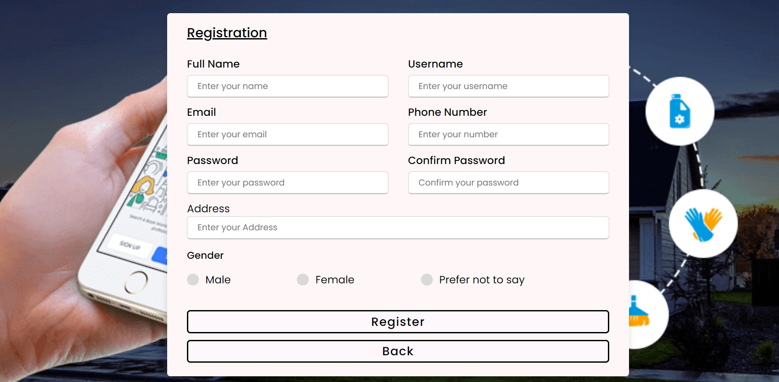

Fig 8.1. Register Page for Customer

* Worker Register Page

In this page, the customer will provide the required information to register.

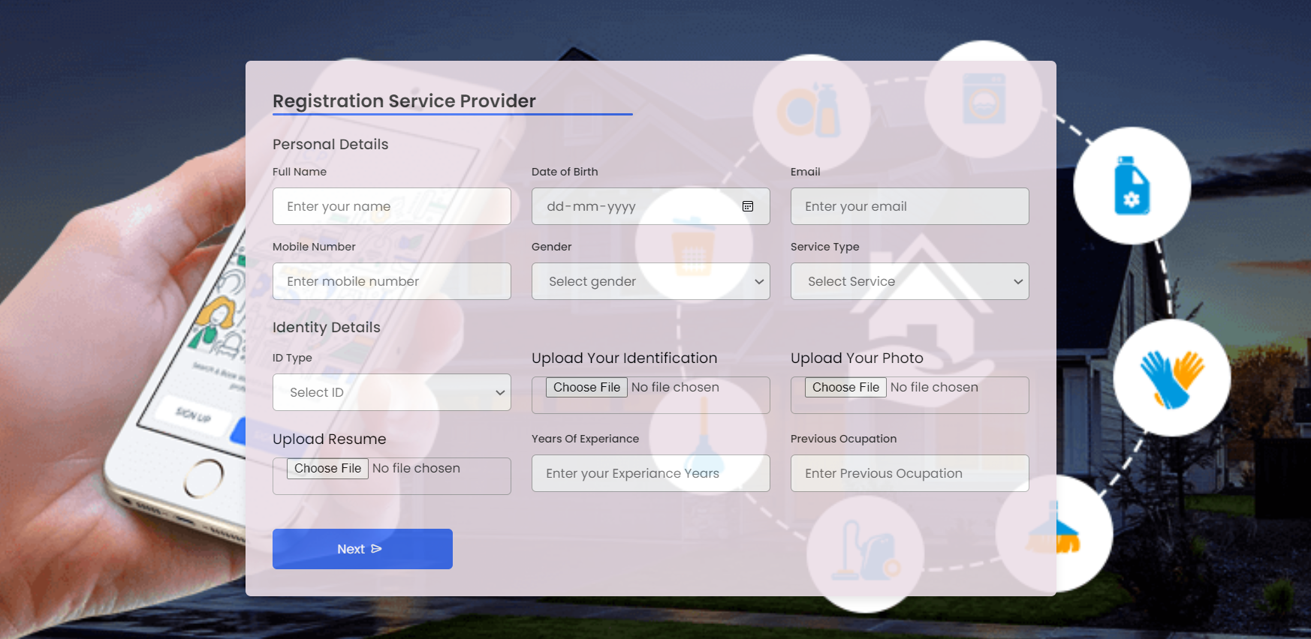

Fig 8.2. Register Page for Customer

* Login Page

The user would be providing the credentials that they created during the register process to log into their account.

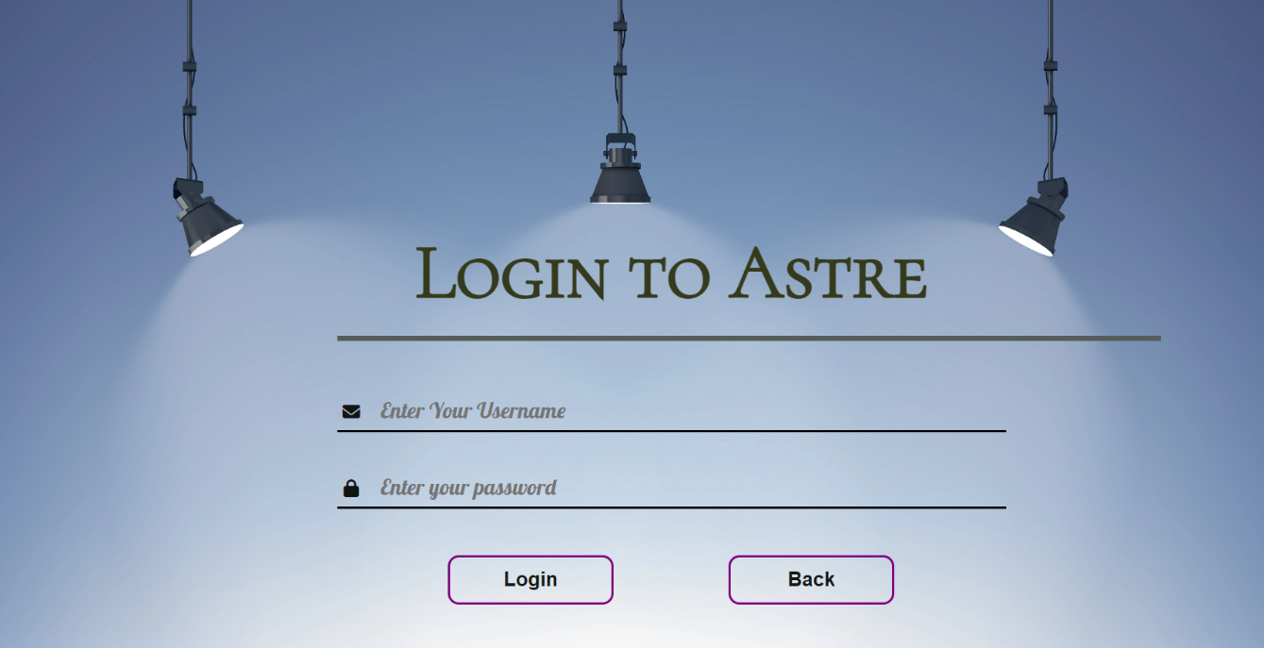

Fig 8.3. Login Page

* Home Page

Home page will be the first page that would be opened for any user and by clicking on the signup button the user can access their account.

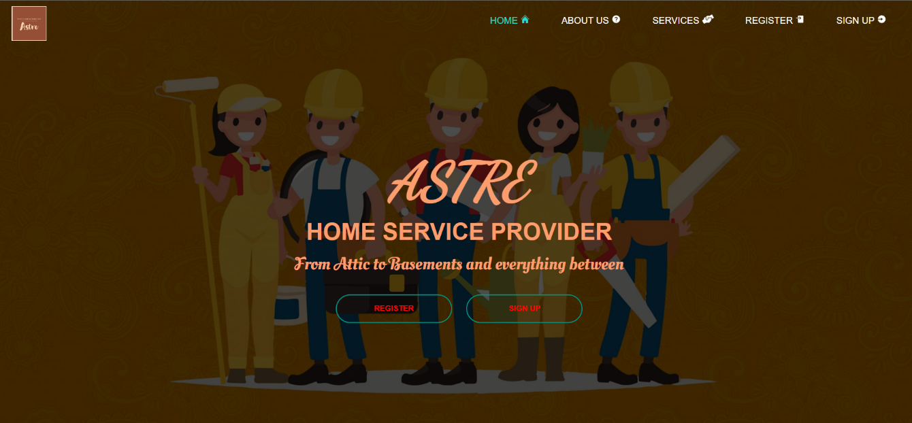

Fig 8.4. Home page before login

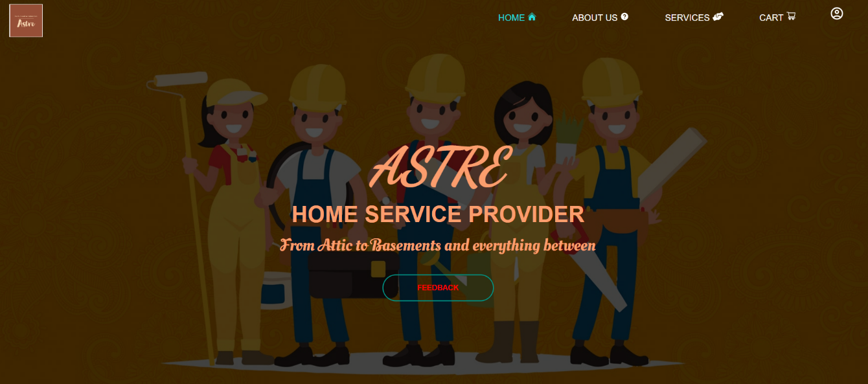

Fig 8.5. Home page after login

* About Us Page

About Us pages display the insights and mission of our website to the users. Through this user can understand the motive behind our website.

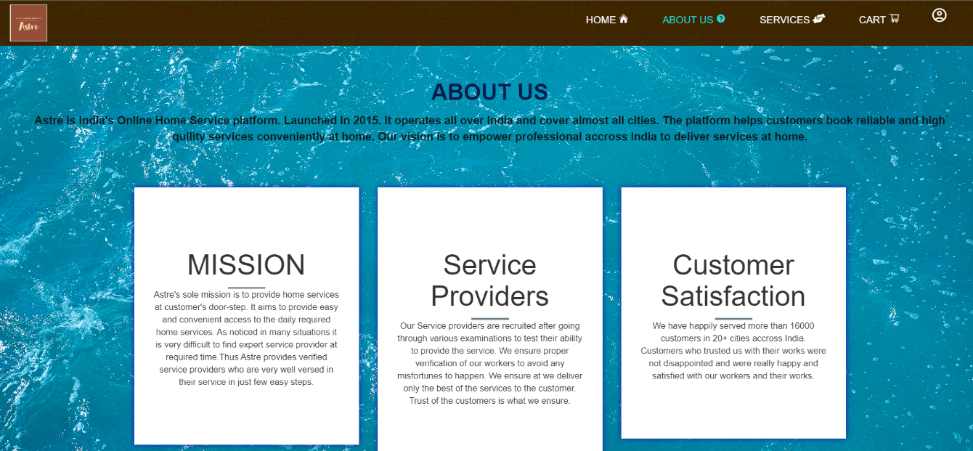

Fig 8.6. About us page

* Service Page

The service page will display all the services available. On selecting a particular service sub-services will be shown.

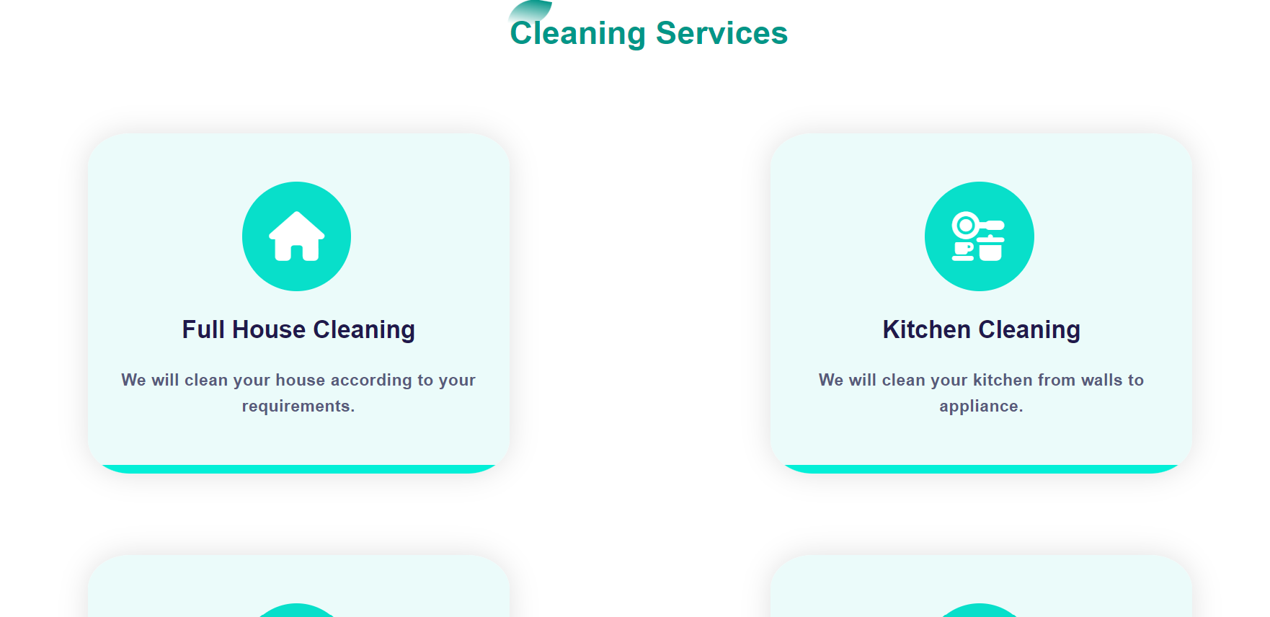

Fig 8.7. Cleaning Service page

* Types of service page

This page will display all the sub-services available under the main serice.

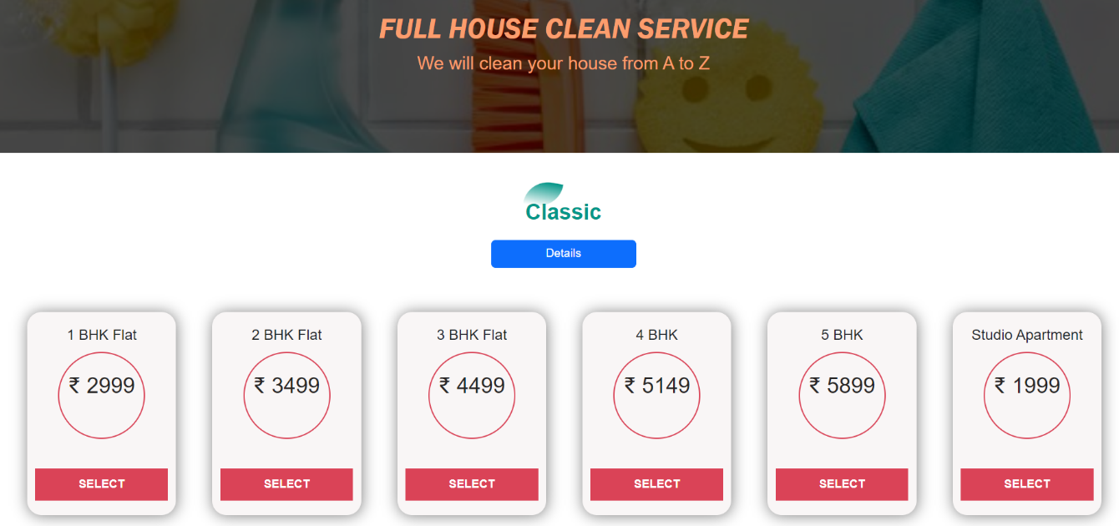

Fig 8.8. Cleaning Service type page

* Cart

In cart the services selected by the customer will be added. Through cart the user can preview all the selected services and then order the service.

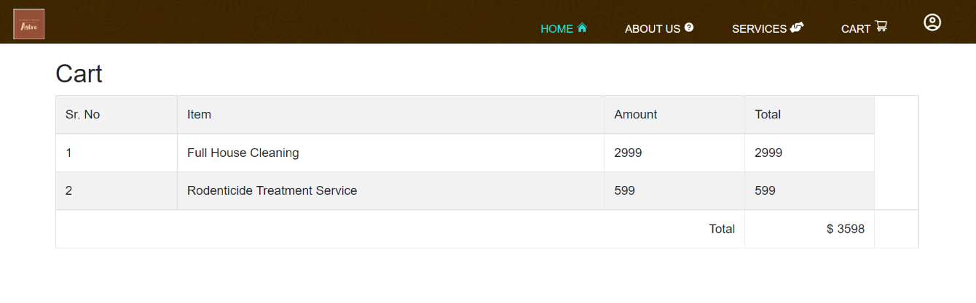

Fig 8.9. Cart page

* Feedback

Through feedback page the user can share their opinion on the service provided by our site and also rate the workers work. This will give a great insight about the user experiences and scope of improvement.

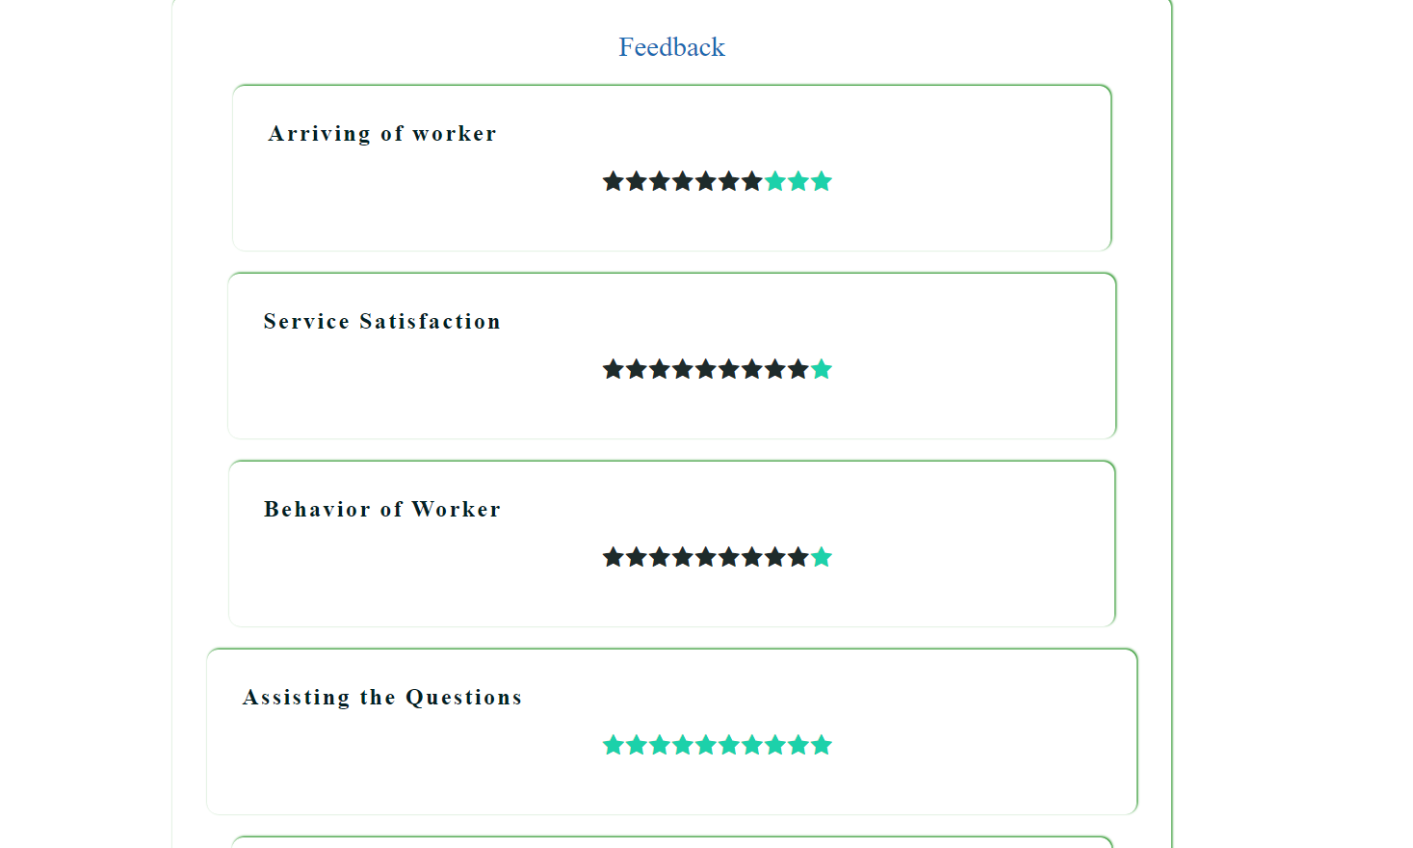

Fig 8.10. Cart page

* Payment portal

Payment portal will help user to play easily for the selected services. There are various payment options and it is easy to understand and use.

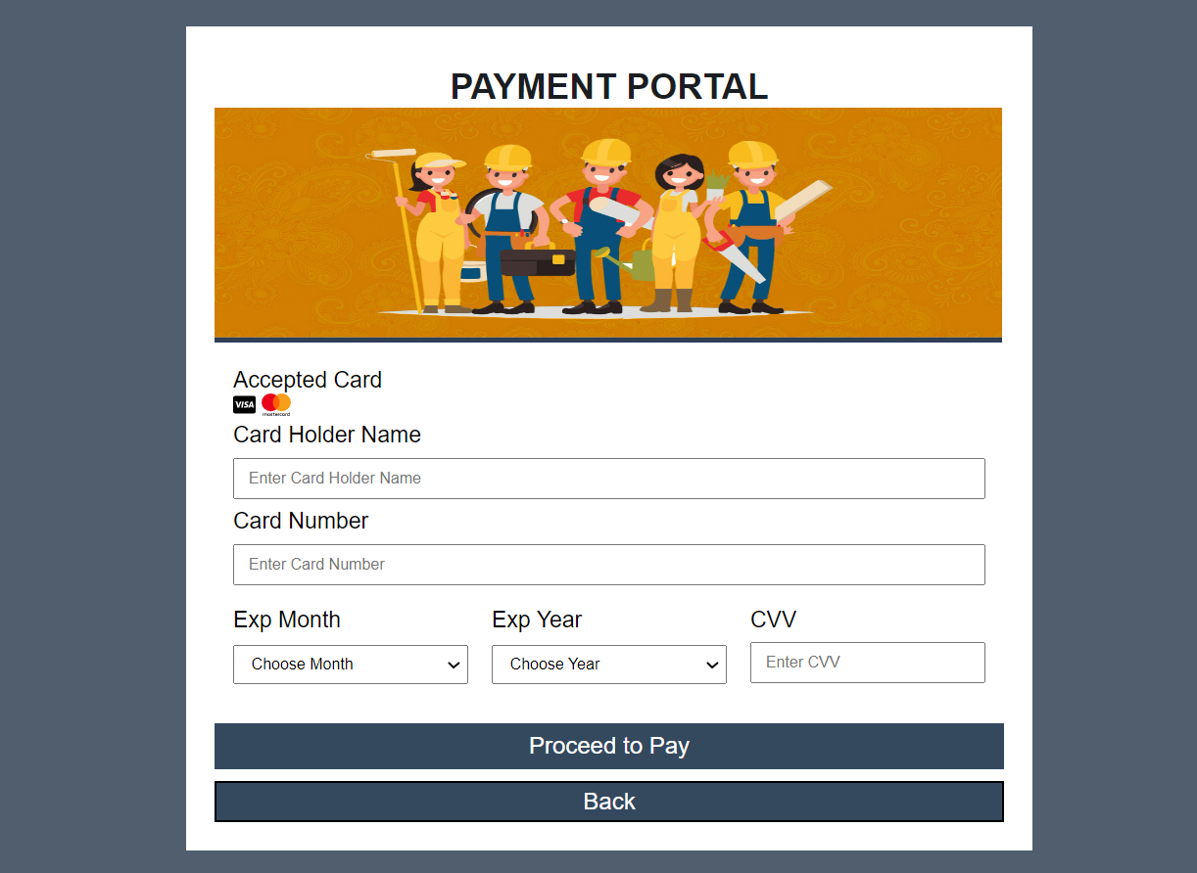

Fig 8.11. Payment page

* Admin Dashboard

Admin dashboard will display all the necessary information about the workers and the customer. The admin can maintain a T0-Do-list and schedule his time a work.

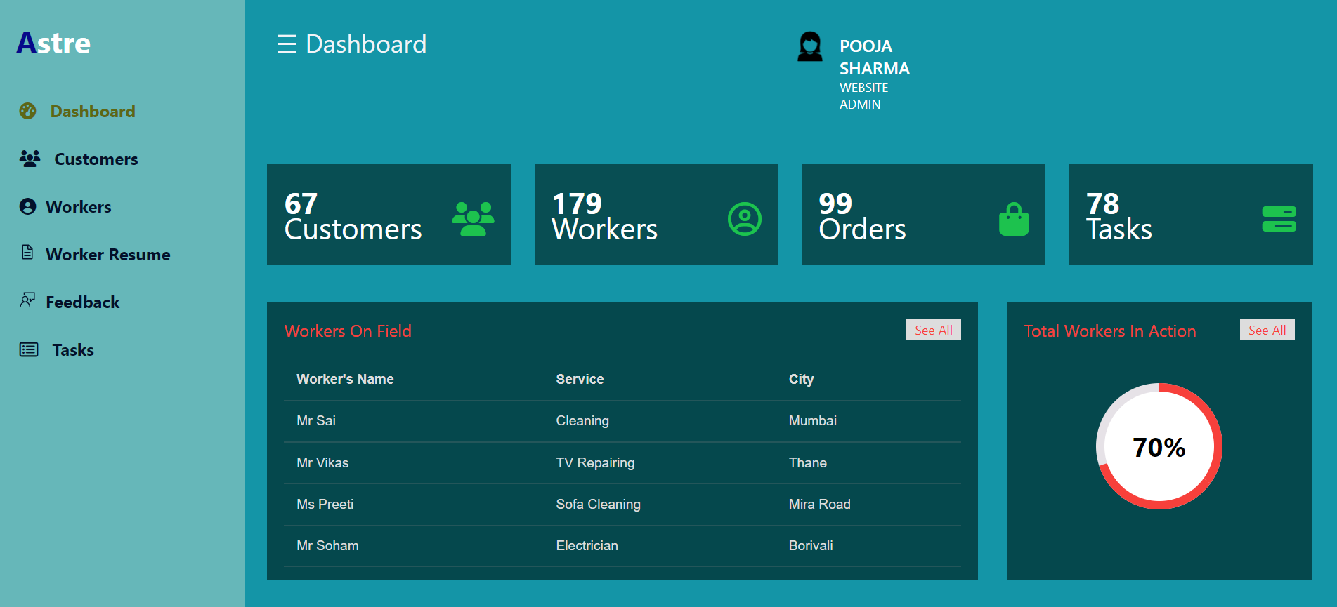

Fig 8.12. Admin Dashboard

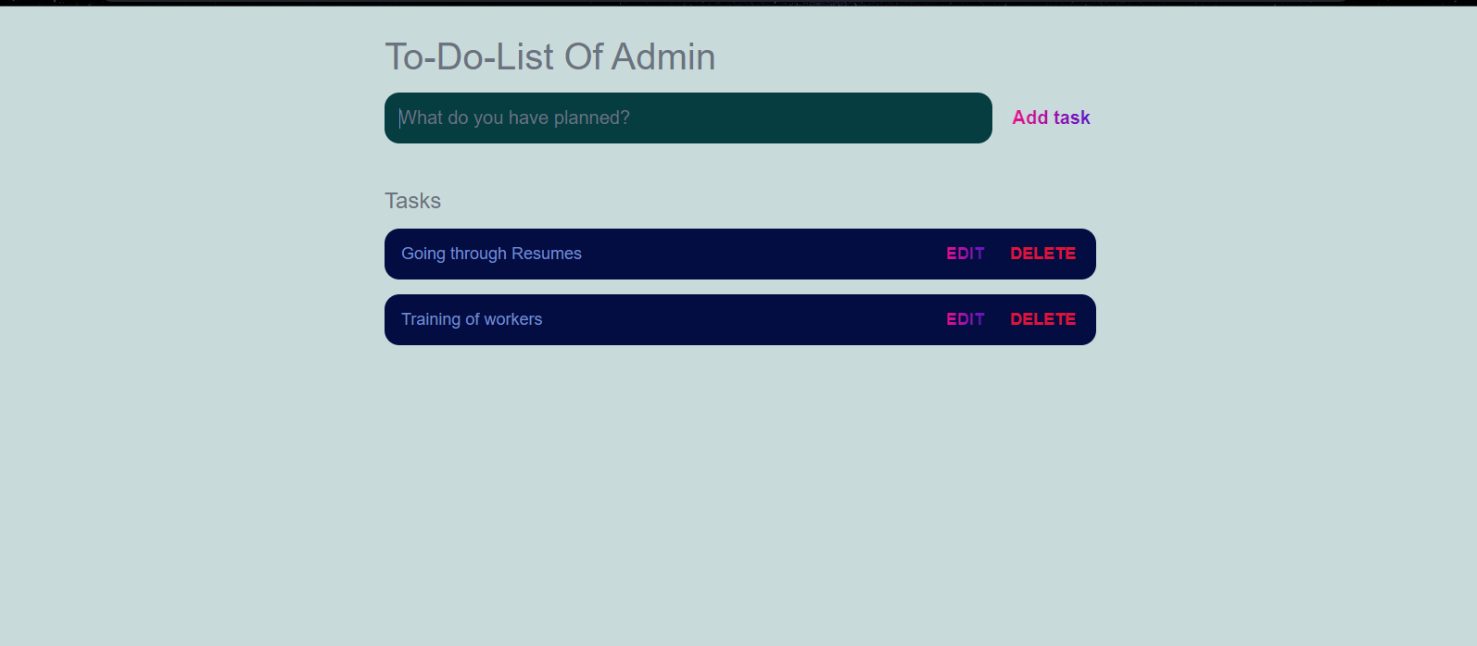

Fig 8.13. Admin To-Do-List

* Worker Dashboard

The woker can keep trak of all the orders and his personal work details in the dashboard

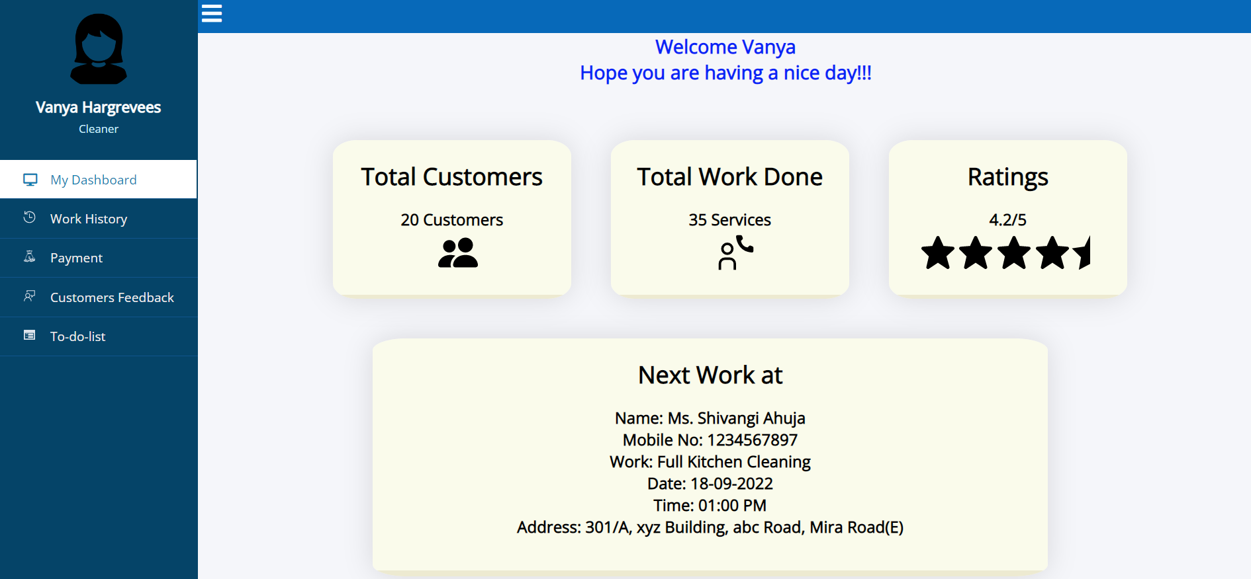

Fig 8.14. Worker Dashboard

Chapter 10

Conclusion and Future Scope

The proposed system provides several services by providing service specialists at one’s doorstep in one click and reduce burden in finding in-house solutions for the services. The online household services application provides some of the home services which are most frequently used. This system accommodates the changing needs of the end user.

The designed website will save customer’s time and also aim to provide the wanted service with reasonable price. The website is designed in such a way that the user will be able to book a service without confusion. Several aspects like painting, pest control, home cleaning, plumbing and electrical works are involved in a system to provide happy and healthy home atmosphere in order to satisfy consumers. A single click system describes booking highly skilled in-house professionals and gets your service done on time.

**Future Scope:**

* The website can be prolonged by adding up the home services.
* The system can have prolonged by adding the services such as mobile and computer repair, laundry services, catering services and many more.
* The website can also have additional payment systems.
* Our project can also be used in other services like beauty service.

References

* International Journal of Engineering Research & Technology (IJERT) ISSN: 2278-0181, Published by, [www.ijert.org](http://www.ijert.org/), NCESC - 2018 Conference Proceedings.
* Shahrzad Shahriari, Mohammadreza Shahriari, Saeid gheiji. “ECommerce And It Impactson Global Trend And Market”.International Journal of Research – Granthaalayah. Vol.3 (Iss.4): April, 2015.
* M. Hills, P. Klint, and J. J. Vinju, “Static, Lightweight Includes Resolution for PHP,” in Proceedings of ASE 2014. ACM, 2014, pp. 503–514
* Mohammed Sayagh, Bram Adams Polytechnique Montreal, Multi-layer Software Configuration: Empirical Study on WordPressSCAM 2015, Bremen, Germany.
* Urban Clap Website <https://www.urbancompany.com/delhi-ncr>